1.Create a table named DEPT1 with the following columns:
DEPTNO INTEGER (Primary Key)
DNAME VARCHAR2(30) NOT NULL
LOC VARCHAR2(30) NOT NULL
Query:
CREATE TABLE dept1(deptno INTEGERCONSTRAINT dept1_pk PRIMARY KEY,
dname VARCHAR2(30)CONSTRAINT dept1_dname_nn NOT NULL,
loc VARCHAR2(30)CONSTRAINT dept1_loc_nn NOT NULL);
Output:
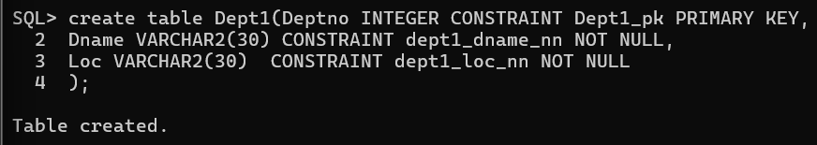

2.Create a table named EMP1 with the following columns:
EMPNO INTEGER (Primary Key)
ENAME VARCHAR2(20) NOT NULL
SAL NUMBER(10,2) with CHECK constraint (SAL > 5000)
MGR NUMBER (Foreign Key referencing EMP1(EMPNO))
DEPTNO INTEGER (Foreign Key referencing DEPT1(DEPTNO))
Query:
CREATE TABLE emp1(empno INTEGER
CONSTRAINT emp1_pk PRIMARY KEY,
ename VARCHAR2(20)CONSTRAINT emp1_ename_nn NOT NULL,
sal NUMBER(10,2)
CONSTRAINT emp1_sal_ck CHECK(sal>5000),
mgr NUMBER,deptno INTEGER,
CONSTRAINT emp1_mgr_fk
FOREIGN KEY(mgr)
REFERENCES emp1(empno),
CONSTRAINT emp1_dept_fk
FOREIGN KEY(deptno)
REFERENCES dept1(deptno));
Output:
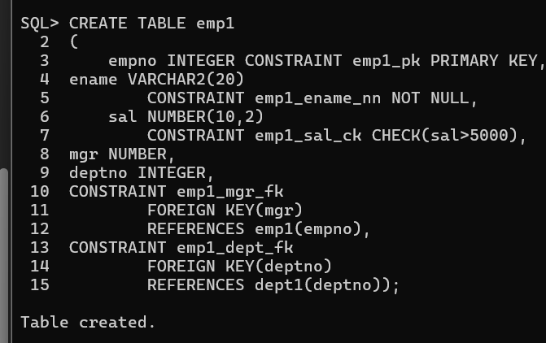

3.Create tables DEPT11 and EMP11 from DEPT1 and EMP1.
Query:
CREATE TABLE dept11 ASSELECT *FROM dept1;
CREATE TABLE emp11 AS SELECT *FROM emp1;
Output:
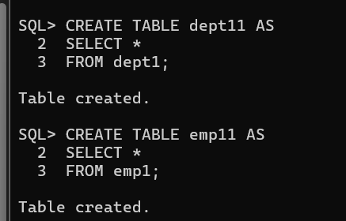

4.Add a new column ADDRESS VARCHAR2(30) to the EMP1 table.
Query:
ALTER TABLE emp1
ADD address VARCHAR2(30);
Output:
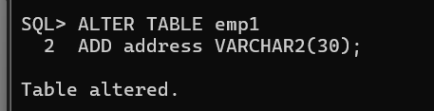

5.Rename the SAL column in the EMP1 table to SALARY.
Query:
ALTER TABLE emp1
RENAME COLUMN sal TO salary;
Output:
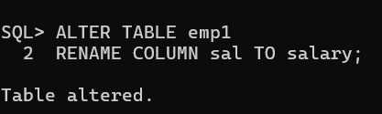

6.Rename the foreign key constraint names in the EMP1 table and verify the new constraint names.
Query:
ALTER TABLE emp1
RENAME CONSTRAINT emp1_mgr_fk TO manager_fk;
ALTER TABLE emp1
RENAME CONSTRAINT emp1_dept_fk TO dept_fk;
SELECT constraint_name
FROM user_constraints
WHERE table_name='EMP1';
Output:
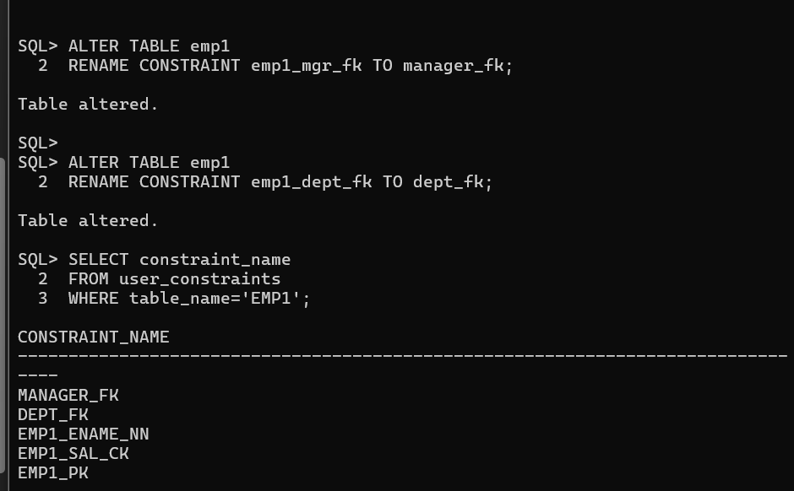

7.Modify the ENAME column by increasing its length to VARCHAR2(40).
Query:
ALTER TABLE emp1
MODIFY ename VARCHAR2(40);
Output:
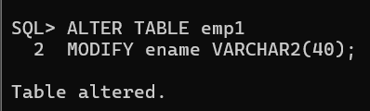
8.Drop the NOT NULL constraint from the ENAME column.
Query:
ALTER TABLE emp1
MODIFY ename NULL;
Output:
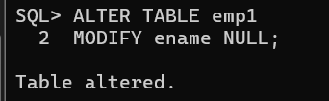
9.Create a comment on the DEPT1 table as 'Depts of WIPRO'.
Query:
COMMENT ON TABLE dept1
IS 'Depts of WIPRO';
Output:
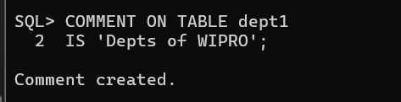

10.Create a comment on the DEPTNO column of the DEPT1 table as 'Deptno of WIPRO'.
Query:
COMMENT ON COLUMN dept1.deptno
IS 'Deptno of WIPRO';
Output:
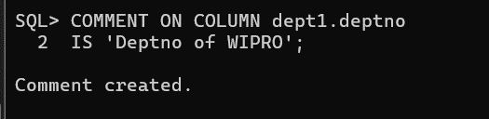
11.Create a comment on the EMP1 table as 'Employees of WIPRO'.
Query:
COMMENT ON TABLE emp1
IS 'Employees of WIPRO';
Output:
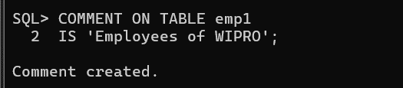

12.Create a comment on the EMPNO column of the EMP1 table as 'Empno of WIPRO'.
Query:
COMMENT ON COLUMN emp1.empno
IS 'Empno of WIPRO';
Output:
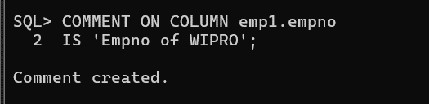
13.Remove all comments from the tables and columns.
Query:
COMMENT ON TABLE dept1 IS '';
COMMENT ON COLUMN dept1.deptno IS '';
COMMENT ON TABLE emp1 IS '';
COMMENT ON COLUMN emp1.empno IS '';
Output: 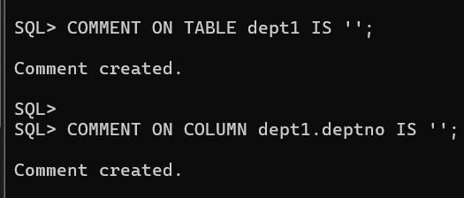
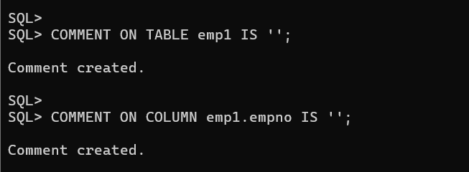
14.Set the SALARY and ENAME columns of the EMP1 table as UNUSED.
Query:
ALTER TABLE emp1
SET UNUSED (salary,ename);
Output:
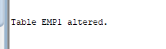

15.Drop the unused columns from the EMP1 table.
Query:
ALTER TABLE emp1
DROP UNUSED COLUMNS;
Output:
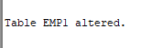

16.Drop the EMP1 and DEPT1 tables.
Query:
DROP TABLE emp1;
DROP TABLE dept1;
Output:
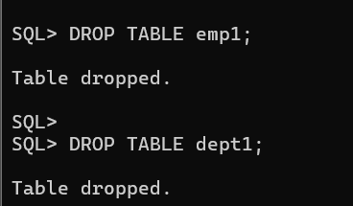
17.Create a table EMP1 from the EMP table by copying both the structure and the data. Verify the copied data.
Query:
CREATE TABLE emp1 AS
SELECT *
FROM emp;
SELECT *
FROM emp1;
Output:
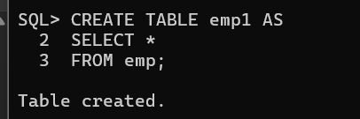
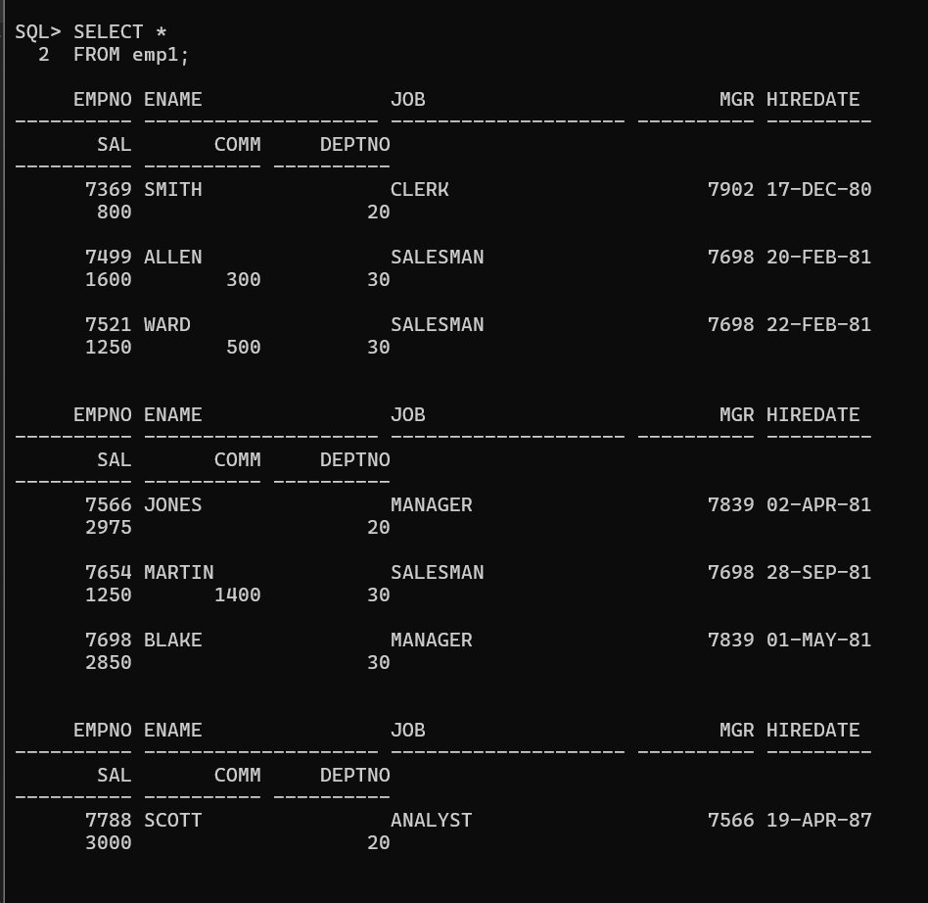
18.Rename the EMP1 table to EMP_TEST.
Query:
RENAME emp1 TO emp_test;
Output:
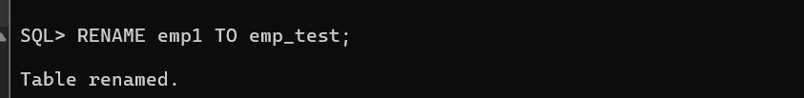

19.Truncate the EMP_TEST table and verify that all rows have been deleted.
Query:
TRUNCATE TABLE emp_test;
SELECT *
FROM emp_test;
Output:
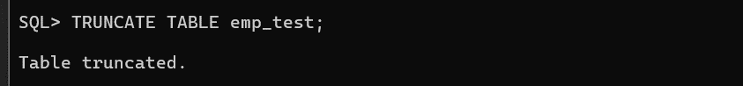
20.Create a table EMP2 from the EMP table by copying only the EMPNO, ENAME, and SAL columns along with their data.
Query:
CREATE TABLE emp2 AS
SELECT empno,ename,sal
FROM emp;
SELECT *
FROM emp2;
Output:
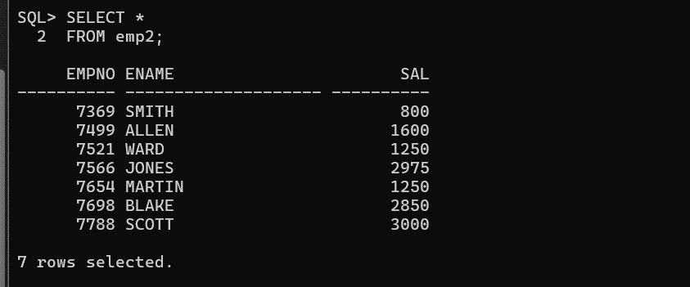

21.Drop the EMP2 table.
Query:
DROP TABLE emp2;
Output:
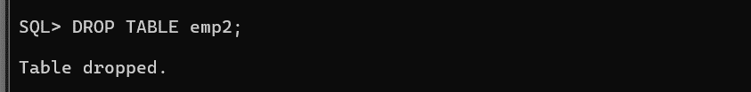
22.Create the EMP2 table again from the EMP table without copying any data.
Query:
CREATE TABLE emp2 AS
SELECT empno,ename,sal
FROM emp
WHERE 1=2;
SELECT *
FROM emp2;
Output:
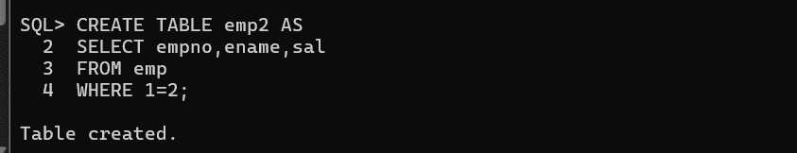

23.Drop the EMP2 table.
Query:
DROP TABLE emp2;
SELECT *FROM emp2;
Output:
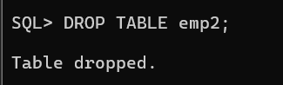

24.Flashback the first EMP2 table (the one that contained data) and verify the restored table.
Query:
FLASHBACK TABLE emp2 TO BEFORE DROP;
SELECT *
FROM emp2;
Output:
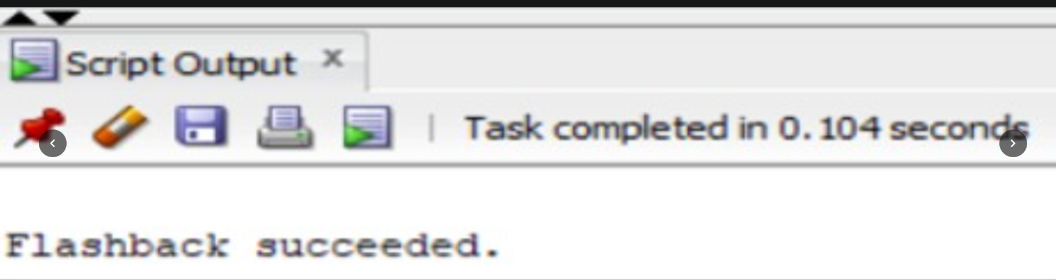
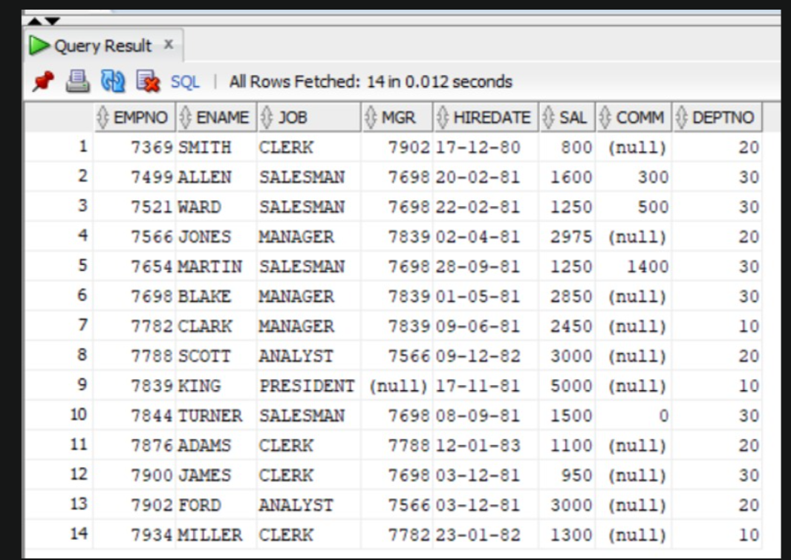
25.Flashback the recently dropped table and rename it to EMP2_1.
Query:
FLASHBACK TABLE emp2
TO BEFORE DROP
RENAME TO emp2_1;
Output:



26.Display all the tables in your current schema using SQL*Plus commands.
Query:
SELECT table_name
FROM user_tables
ORDER BY table_name;
SELECT *
FROM tab;
Output:
